Customer Shopping Behaviour Analysis
- Project Overview
The Customer Behavior Analysis project aims to analyze customer shopping patterns and generate business insights using Python, PostgreSQL, SQL, and Power BI. The dataset contains 100 customer data entries including demographics, purchase details, product categories, payment methods, subscriptions, discounts, and shopping frequency.

Python was used for data cleaning and preprocessing, PostgreSQL and SQL were used for database management and analysis, and Power BI was used to create interactive dashboards and visualizations.

The project helps understand customer preferences, spending behaviour, revenue trends, and product performance while demonstrating a complete end-to-end data analytics workflow.

- Dataset Summary
- Row : 100
- Columns : 18
- Key Features :
- Customer demographics (Age, Gender, Location, Subscription Status)
- Purchase details (Item Purchased, Category, Purchase Amount, Season, Size, Colour)
- Shopping behaviour (Discount Applied, Promo Code Used, Previous Purchases, Frequency of Purchases, Review Rating, Shipping Type, Payment Method)
- Missing Data :
- Null values were present in some columns and handled during data preprocessing using mean, median, and mode techniques.

- Exploratory Data Analysis using Python
We began with data preparation and cleaning in Python.
• Data Loading: Imported the dataset using pandas.
• Initial Exploration: Used df.info() to check data structure and describe() for summary statistics.
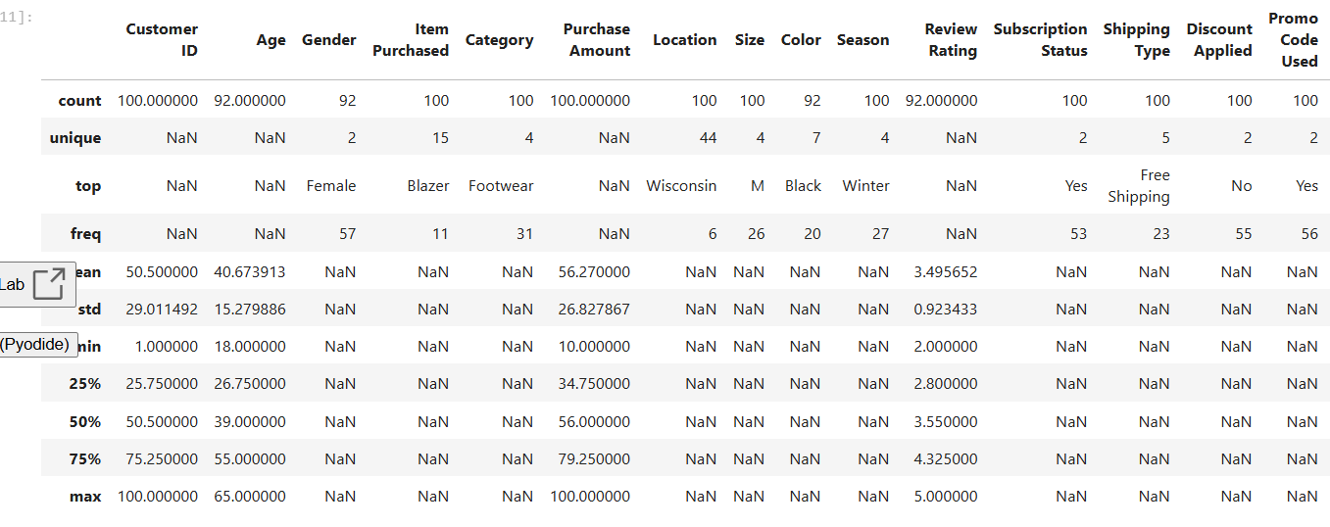
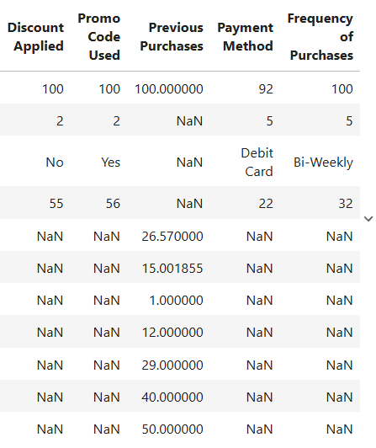
• Missing Data Handling: Checked for null values and filled missing values in the review_rating column using appropriate techniques.
• Column Standardization: Renamed column names into snake_case format for better readability and SQL compatibility.
• Feature Engineering:
○ Created age_group column by categorizing customer ages.
○ Created purchase_frequency_days column from purchase frequency data.
• Data Consistency Check: Verified whether discount_applied and promo_code_used were redundant and removed unnecessary columns.
• Database Integration: Connected Python with PostgreSQL and loaded the cleaned dataset into the customer table for SQL analysis.
• Visualization Preparation: Imported the PostgreSQL dataset into Power BI for dashboard creation and business insight generation.
- Data Analysis using SQL
We performed structured analysis in PostgreSql to answer key business questions.
- Revenue by Gender – compared total revenue generated by male vs. female customers.
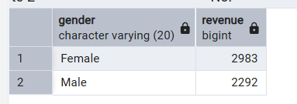

- High-Spending Discount Users – identified customers who used discount but still spent above the average purchase amount.
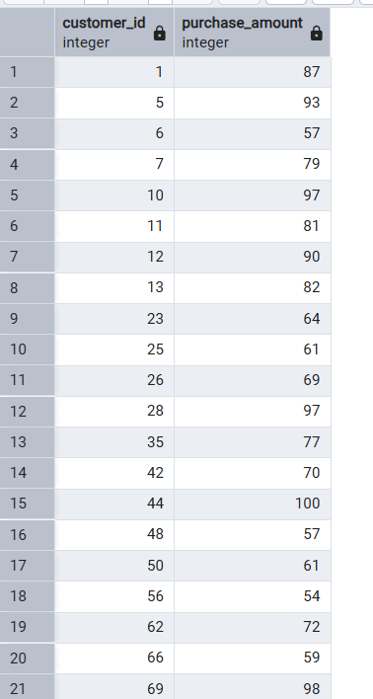
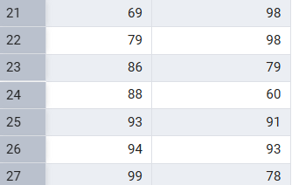
- Top 5 High-Value Products - Analyzed products with the highest average review ratings.
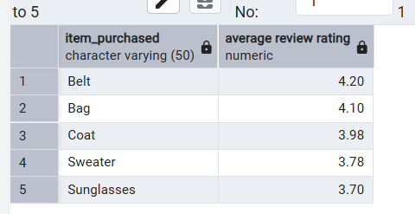
- Shipping Type Comparison – compared average purchase amounts between standard and express shipping.
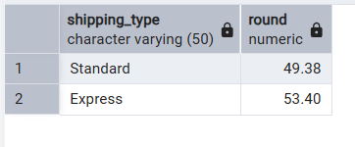
- Subscribers vs. Non-Subscribers – compared average spend and totalrevenue across subscription status.
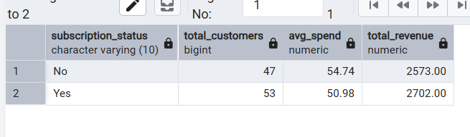
- Top Discounted Products – Identified products with the highest percentage of discount usage.
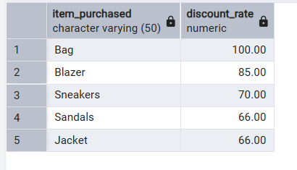
- Customer Segmentation – Segmented customers into new, returning, and loyal categories based on previous purchases.
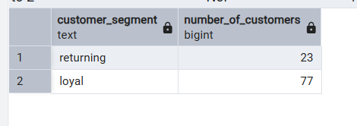
- Repeat Buyer Analysis – Analyzed whether repeat buyers were more likely to subscribe.
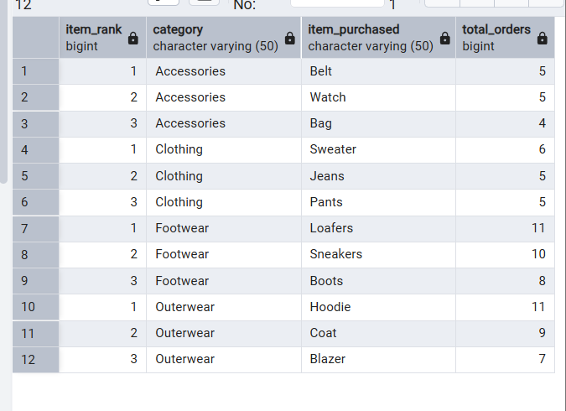
- Top Purchased Products by Category – Identified the top 3 most purchased products within each category.
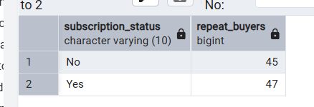
- Revenue Contribution by Age Group – Compared revenue generated across different customer age groups.
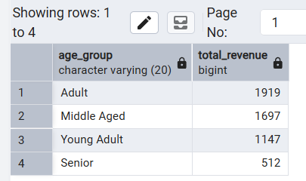

- Dashboard
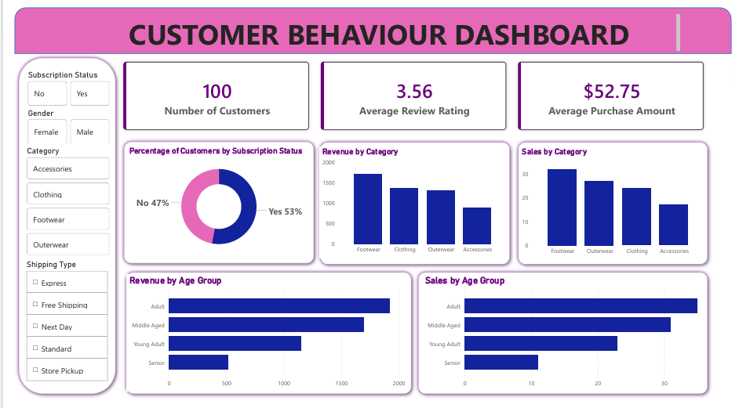

- Bussiness Recommendations
Customer Loyalty Programs – Reward frequent buyers with loyalty points, discounts, or membership benefits to encourage repeat purchases.
Review Discount Strategies – Use discounts strategically to increase sales while maintaining profit margins.
Product Positioning – Highlight top-selling and highly rated products in marketing campaigns to improve customer engagement.
Targeted Marketing – Focus marketing efforts on high-spending customer groups based on age, category preferences, and shopping behaviour.
Boost Subscriptions – Promote exclusive offers and benefits for subscribed customers to increase customer retention and revenue.

